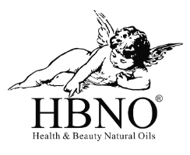

<h1>Essential Oils</h1>
Lorem ipsum is placeholder text commonly used in the graphic, print, and publishing industries for previewing layouts and visual mockups.
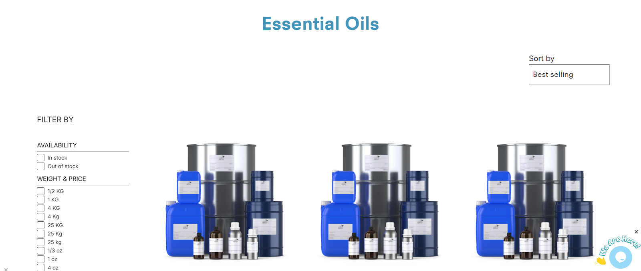

(Reference: https://www.hbnobulk.com/collections/essential-oils-products )

View All Essential Oils

<h2>Learn About Essential Oils</h2>
Essential oils are highly concentrated plant extracts that capture the natural scent and beneficial properties of herbs, flowers, and other botanicals. They're commonly used in aromatherapy, skincare, and natural remedies.

<h2>Types of Essential Oils</h2>
Essential oils come in many types, each with unique benefits. Here are some common categories:

<h3>Floral Oils </h3>
These essential oils help relax the mind and body, ease stress, and promote better sleep.

Examples: Lavender oil, Rose oil, Jasmine oil.

<h3>Citrus Oils</h3>
These oils boost mood, increase energy, and create a fresh, vibrant atmosphere.

Examples: Lemon oil, Orange oil, and Bergamot oil.

<h3>Herbaceous Oils</h3>
These oils help cleanse the air, support mental clarity, and restore emotional balance.

Examples: Rosemary oil, Basil oil, and Clary Sage Oil.

<h3> Spice Oils </h3>
These essential oils promote circulation, boost energy, and create a cozy, invigorating feeling.

Examples: Cinnamon oil, Clove oil, and Ginger oil.

<h3>Woodsy Oils </h3>
These oils help reduce stress, promote stability, and support a sense of inner peace.

Examples: Cedarwood oil, Sandalwood oil, and Pine oil.

<h3>Resinous Oils </h3>
These oils enhance spiritual practices, encourage mindfulness, and create a peaceful, reflective atmosphere.

Examples: Frankincense oil and Myrrh oil.

<h3>Minty Oils</h3>
These oils refresh the senses, boost alertness, and provide a cooling sensation.
Examples: Peppermint oil and Spearmint oil.

<h2>Features and Application of Essential Oil</h2>

<h3>Key Features of Our Essential Oils</h3>
- 100% Natural Botanical Extracts
Sourced from premium-grade plants, flowers, herbs, and fruits to ensure quality and authenticity in every batch.
- Therapeutic-Grade Aromatic Profiles
Rich, potent scents ideal for use in branded aromatherapy, wellness, and lifestyle product lines.
- Highly Concentrated Formulas
Designed for efficiency—small volumes deliver strong performance across applications.
- Multi-Industry Versatility
Suitable for integration into diffuser blends, massage oils, skincare, spa products, and natural cleaning solutions.
- Free from Synthetics and Additives
Clean formulations meet market demand for purity, safety, and transparency—ideal for clean-label product development.

<h3>Common Application of Essential Oil</h3>
- Stress Relief & Relaxation Support
Ideal for wellness and spa brands—formulations featuring Lavender or Chamomile help address demand for stress-reducing solutions.
- Mood Elevation & Cognitive Clarity
Lemon and Peppermint oils are frequently used in formulations targeting focus, energy, and emotional well-being.
- Sleep Enhancement
Jasmine and Sandalwood blends are suited for nighttime or calming product lines, supporting natural sleep cycles.
- Immune & Respiratory Support
Tea Tree and Eucalyptus oils align with consumer interest in immunity and air-purifying wellness products.
- Skincare & Haircare Enhancement
Rose and Frankincense oils offer antioxidant and soothing properties, making them ideal for premium personal care formulations.
- Eco-Friendly Home Care Solutions
Citrus and Pine oils deliver natural fragrance and antimicrobial properties, suitable for green cleaning and air freshening products.

<h2>Industries That Use Essential Oils</h2>
- Personal Care and Cosmetics
- Aromatherapy and Wellness
- Health and Spa
- Home Fragrance and Cleaning
- Food and Beverage
- Pet and Animal Care
- Textile and Lifestyle Brands

<h2>How to Store Essential Oils Properly</h2>

<h3>Use Dark Glass Bottles</h3>
Store oils in amber or cobalt glass to protect against UV light and oxidation.

<h3>Keep in a Cool, Dry Place</h3>
Ideal storage temperature: 10–25°C (50–77°F). Avoid heat, humidity, and direct sunlight.

<h3>Seal Tightly</h3>
Ensure caps are securely closed to prevent air exposure and evaporation.

<h3>Avoid Plastic Containers</h3>
Essential oils can degrade plastics and compromise purity.

<h3>Label Clearly</h3>
Include batch number, botanical name, and expiration date for traceability and inventory control.

<h2>How to Choose the Right Essential Oil</h2>
When choosing the right essential oil, it’s important to consider your intended use—whether it’s for skincare, aromatherapy, home care, or wellness products. Start by identifying the therapeutic properties you need.
Always prioritize 100% pure, unadulterated oils and verify sourcing details and testing documentation like GC/MS reports to ensure quality and safety. Make sure the oil is compatible with your formulation and aligns with regulatory standards for your industry.
Staying in tune with market trends can also help guide selection. For businesses seeking reliable supply, HBNO Bulk offers a wide selection of high-quality essential oils suitable for wholesale, private label, and large-scale manufacturing needs.

<h2>FAQs About Essential Oils</h2>

Question No.1: Lorem ipsum dolor sit amet, consectetur adipiscing elit, sed do eiusmod tempor incididunt ut labore et dolore magna aliqua.

Question No.2: Lorem ipsum dolor sit amet, consectetur adipiscing elit, sed do eiusmod tempor incididunt ut labore et dolore magna aliqua

Question No.3: Lorem ipsum dolor sit amet, consectetur adipiscing elit, sed do eiusmod tempor incididunt ut labore et dolore magna aliqua

Question No.4: Lorem ipsum dolor sit amet, consectetur adipiscing elit, sed do eiusmod tempor incididunt ut labore et dolore magna aliqua

Question No.5: Lorem ipsum dolor sit amet, consectetur adipiscing elit, sed do eiusmod tempor incididunt ut labore et dolore magna aliqua

<h2>Certificate of Authenticity</h2>

(Reference: https://bulknaturaloils.com/oils.html?p=8 )

